Library Management Database

***Hema***

*2021-08-08 21:48:09*

--------------------------------------------

Write the Attributes of the entities as Bullet points or list.

That will look neat and good.

Library Management Database has the following description:

The Library Management System database keeps track of readers with the following considerations –

* The system keeps track of the staff with a single point authentication system comprising login Id and password.
* Staff maintains the book catalog with its ISBN (International standard book number), Book title, price (in INR), category (novel, general, and story), edition, author Number and details.
* A publisher has publisher Id, Year when the book was published, and name of the book.
* Readers are registered with their User ID, email, name (first name, last name), Phone no (multiple entries allowed), communication address. The staff keeps track of readers.
* Readers can return/reserve books that stamps with issue date and return date. If not returned within the prescribed time period, it may have a due date too.
* Staff also generate reports that has Readers ID, Registration no of report, book no and return/issue info.

Write the Attributes of the entities as Bullet points or list. That will look neat and good.

## Entities and their Attributes –

* **Book Entity:** It has Book_ID,Author_no,Author_ multi valued attribute, ISBN_no, Title, Edition, Category, Price,Subject,Publisher_ID,Country_of_publication,Purchage_date,Gifted (yes or no),Volume_no,Reserved(yes or no),Reserved_date,Issue_date.Book_ID is the Primary Key for Book Entity.
* **User Entity:** It has User ID, Email, address, phone_no, User_name,User_type,User_gender,User_date of birth,User_department,Fine_amount. Name is composite attribute of first_name,middle_name,last_name. Phone_no is multi valued attribute. User ID is the Primary Key for User entity.
* **Publisher Entity:** It has Publisher_ID, Publisher_name,Publisher_address, Year of publication. Publisher ID is the Primary Key.
* **Staff Entity:** It has Staff_name,Staff_ID, Staff_type, Staff_date of birth, Staff_department,Staff_address,Staff_phone number,Staff_Gender,Staff_joining date,Staff_salary,Staff_ID as Primary Key.
* **Author Entity:** It has Author_id, Author_name, Country, Date_of_birth

***Hema***

*2021-08-08 21:48:55*

--------------------------------------------

This is Very good. can add some more description if possible

## Relationships between Entities –

This is Very good. can add some more description if possible

* A User can reserve N books but one book can be reserved by only one User. The relationship 1:N.
* A publisher can publish many books but a book is published by only one publisher. The relationship 1:N.
* Staff keeps track of readers. The relationship is M:N.
* Staff maintains multiple Books. The relationship 1:N.
* A user can borrow multiple books.
* Multiple books belongs to publisher.
* An author can have multiple books.
* A user can received multiple books.
* Book is borrowed by user.

# Library database ER Diagram:

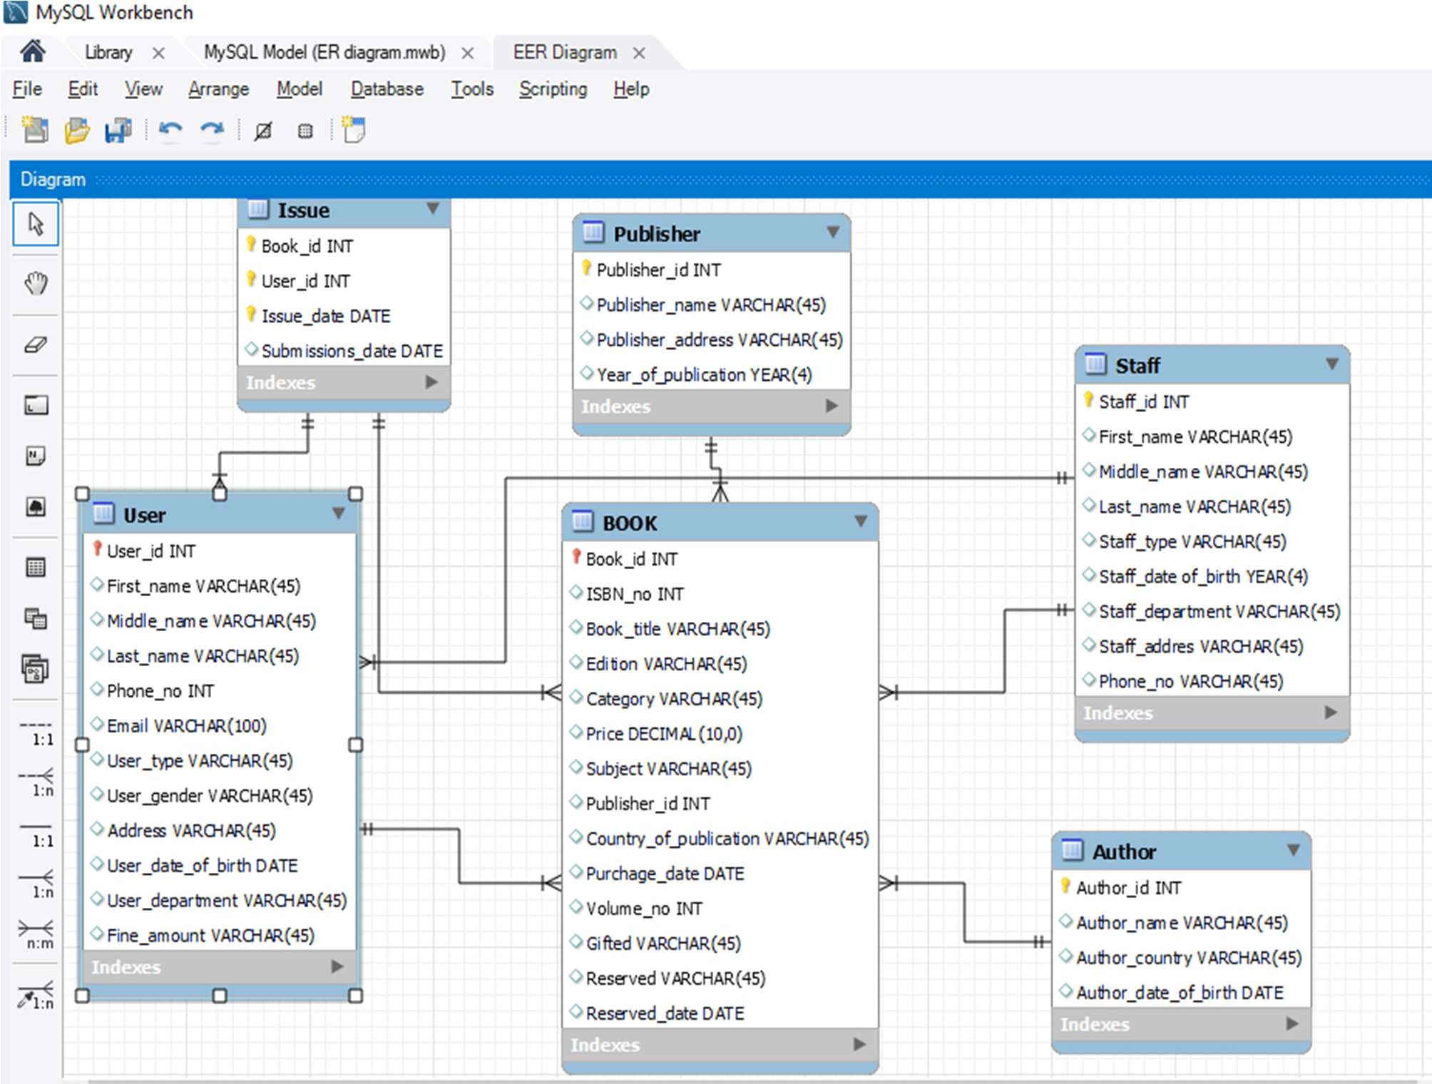

**Schema details:**

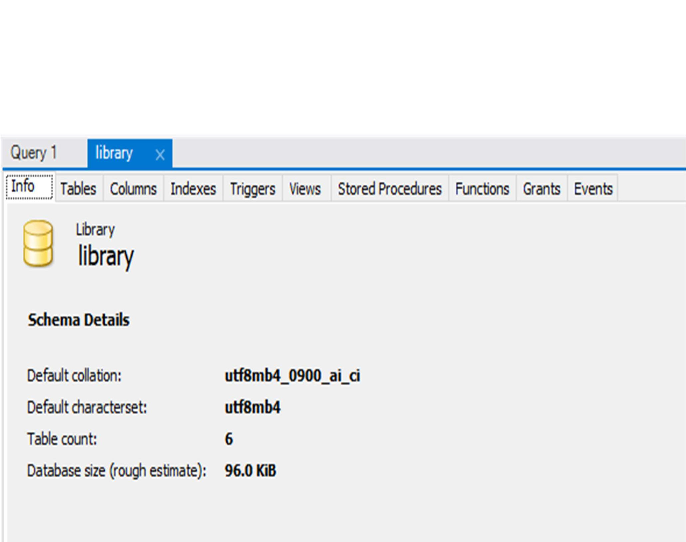

**Table Structure:**

***Hema***

*2021-08-08 21:50:43*

--------------------------------------------

Don't use the yellow Color Font.

They will not get printed when you print them. use different color./

**Author table**:

Don't use the yellow Color Font.

They will not get printed when you print them. use different color./

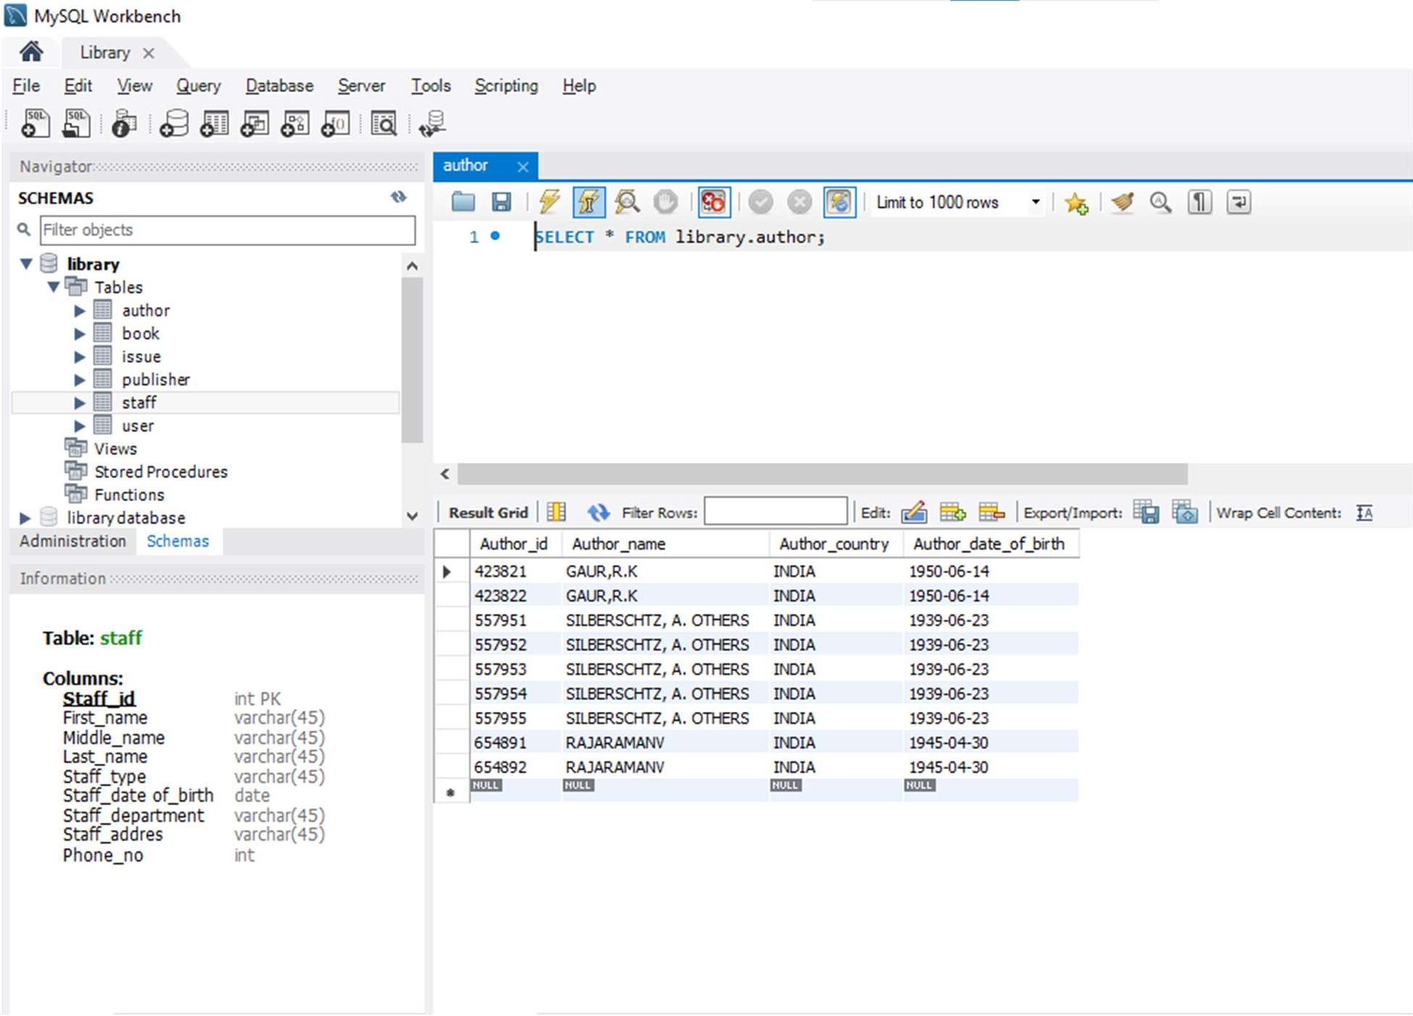

**Book table**:

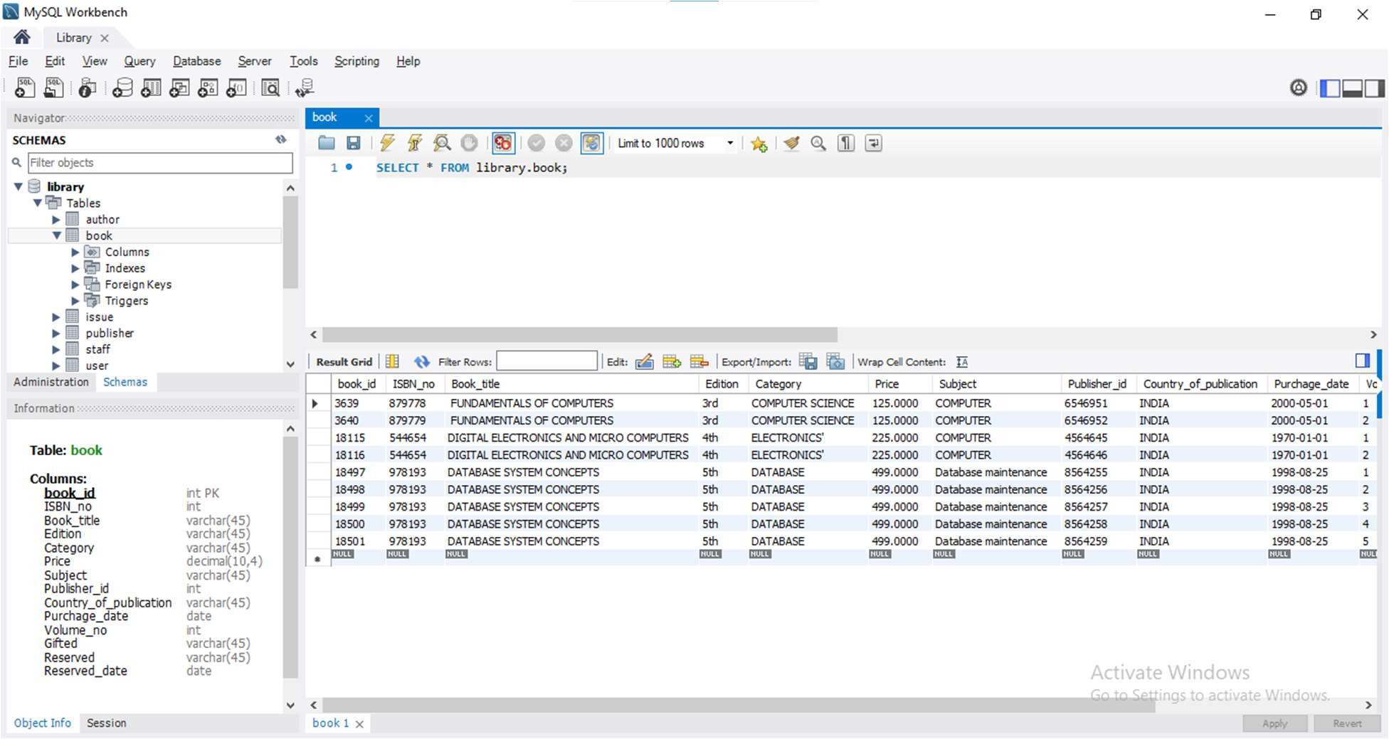

**User table:**

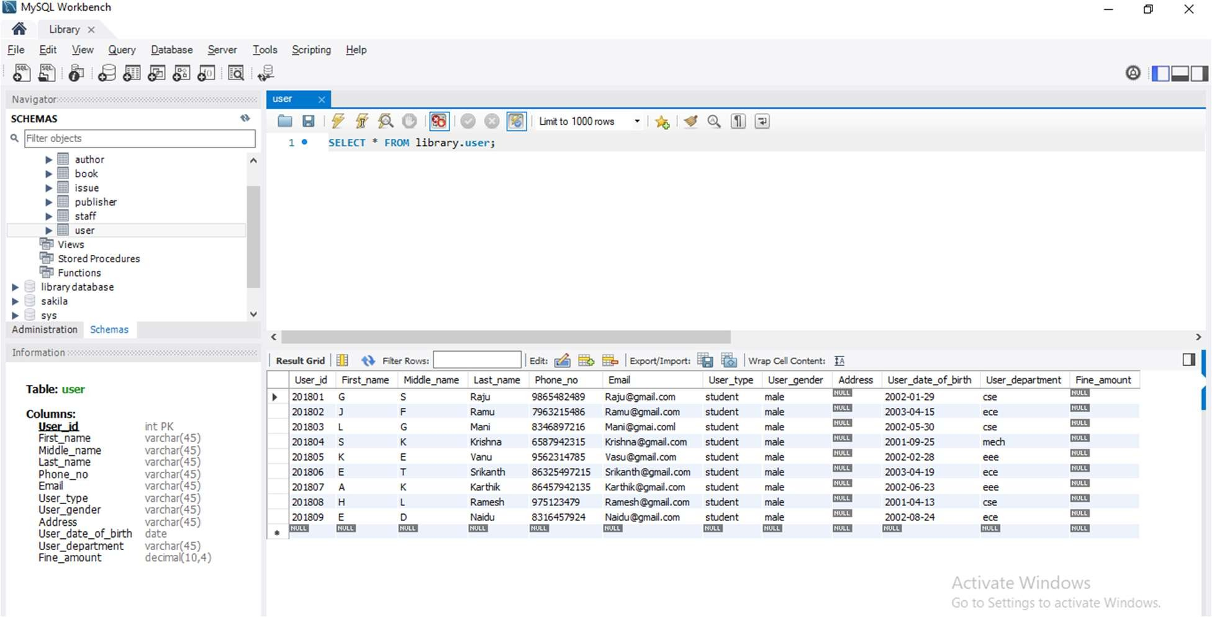

**Issue table:**

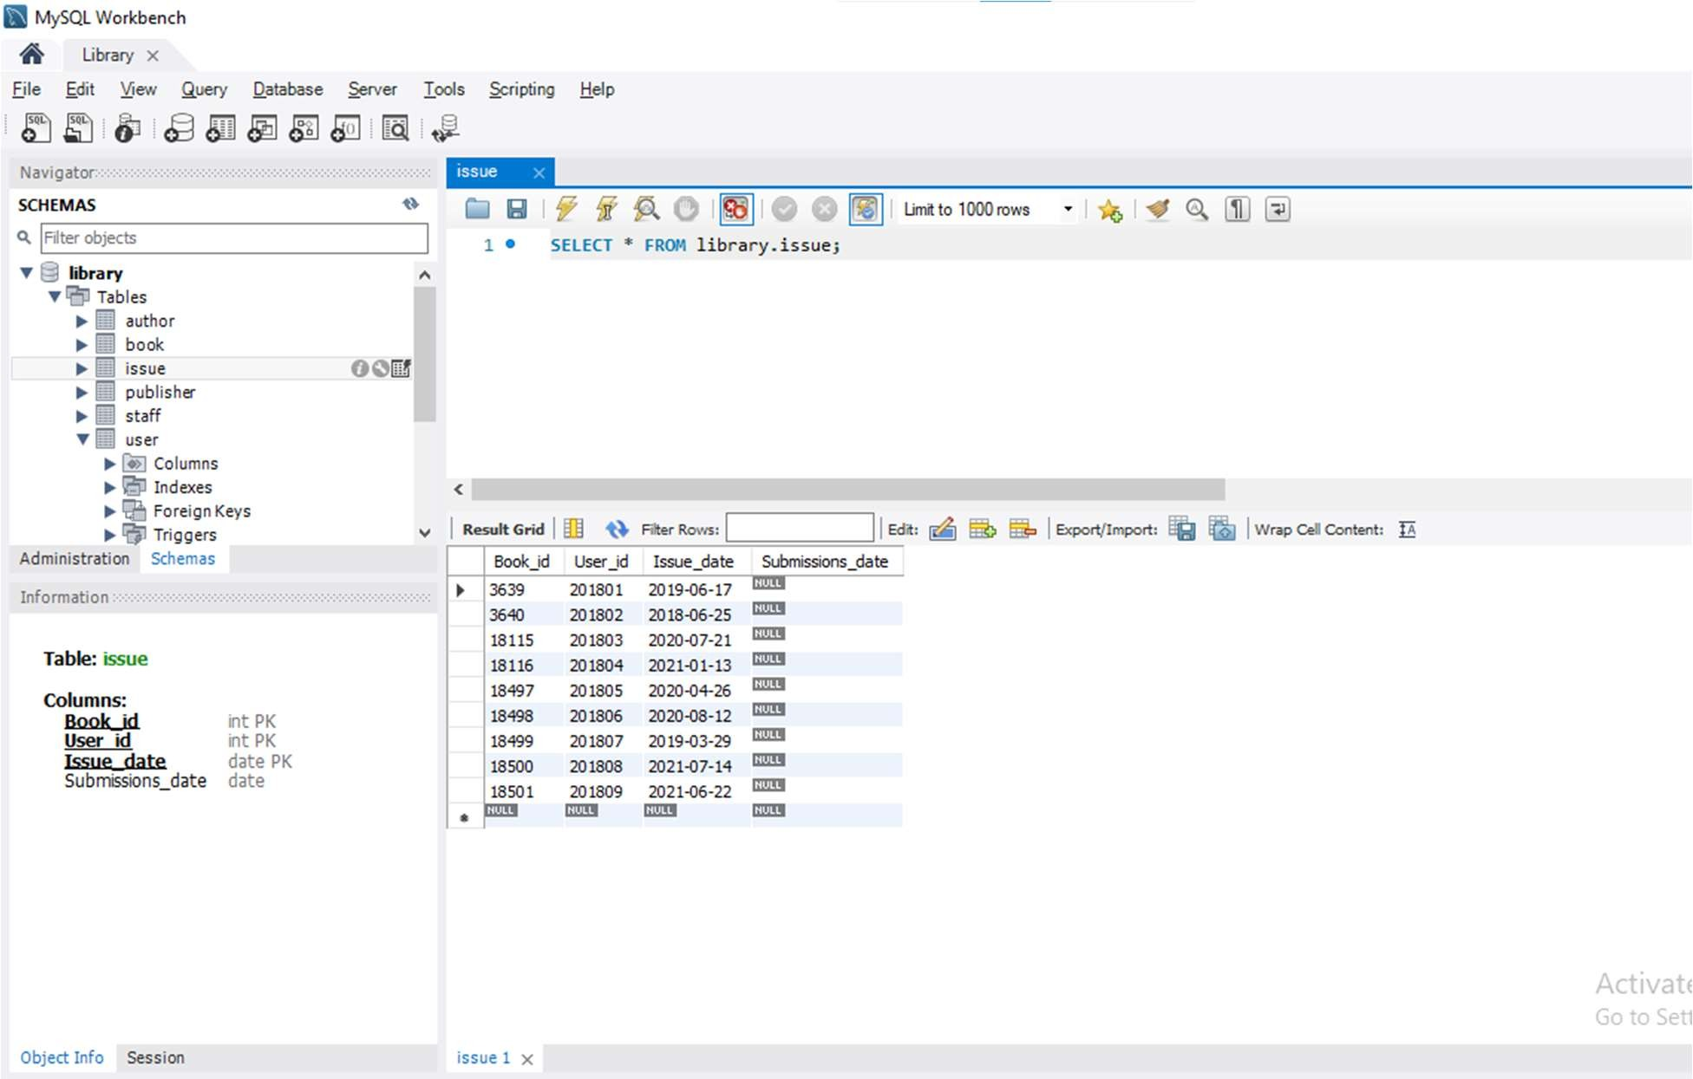

# Staff table:

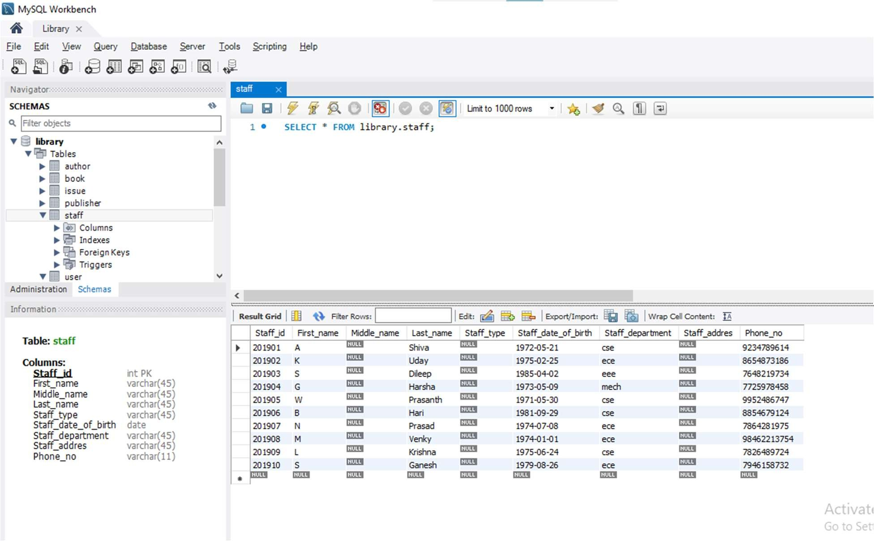

**Publisher table:**

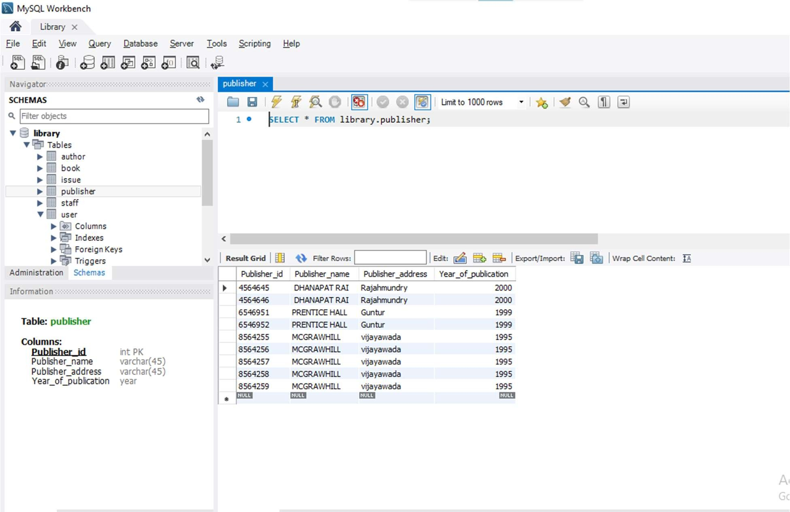

**Queries and demonstrate of the Library Management Database**

**Using library data base show tables in it. Query-1:**

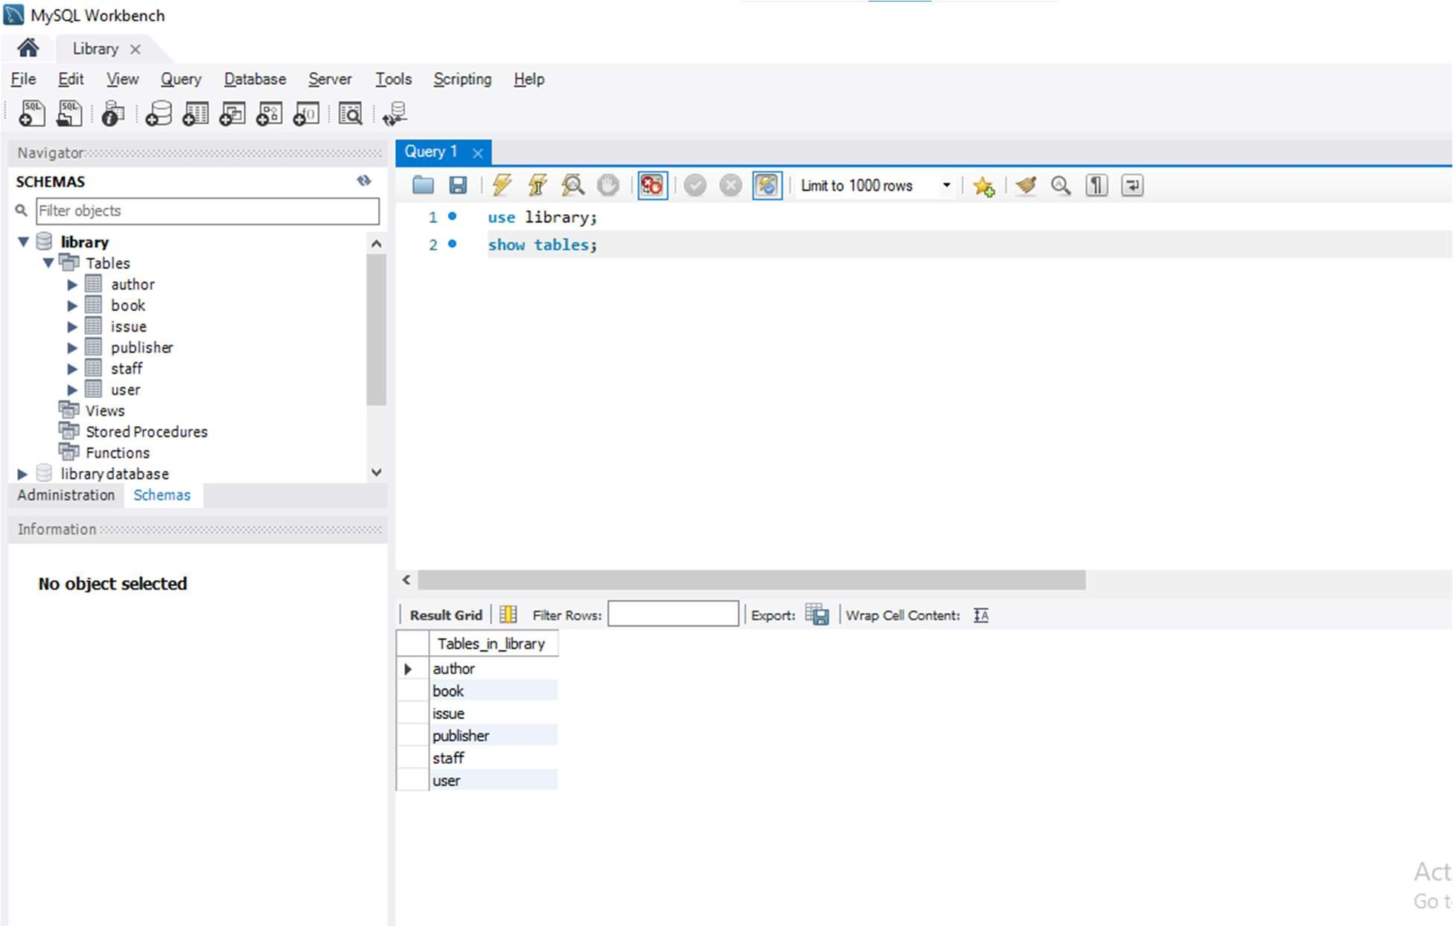

**Using library data base showing book table**: **Query-2:**

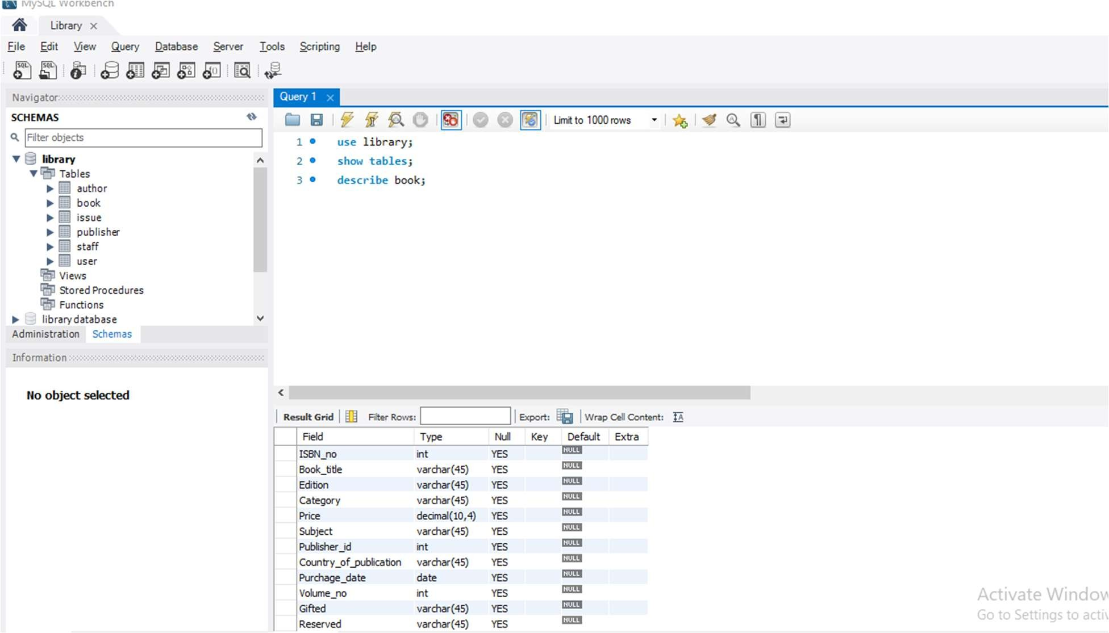

**Showing described values in the book tables: Query-3:**

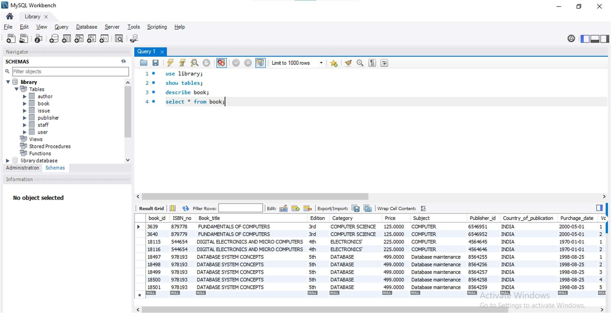

**Showing some columns in the book table Query-4:**

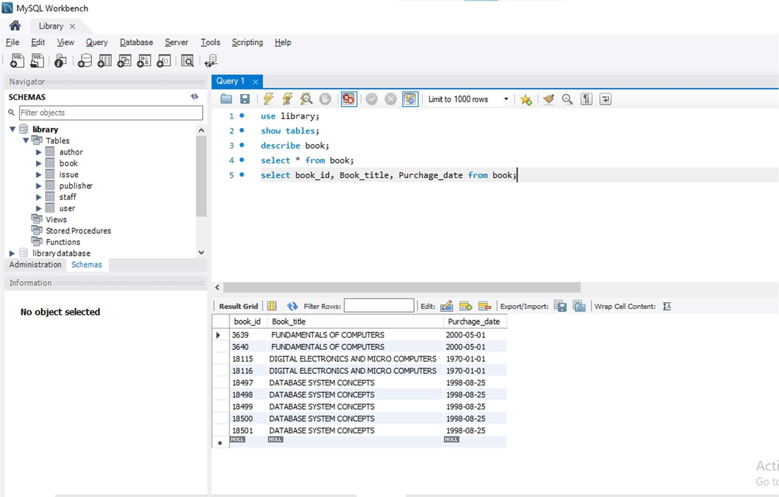

**Showing Publisher_id and Publisher_name in Publisher tables order by Publisher_name**

**Query-5:**

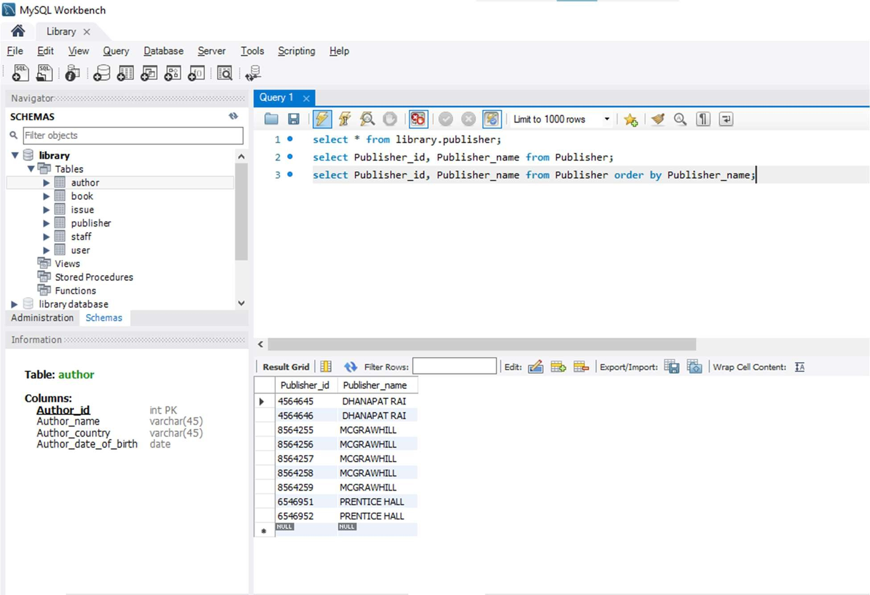

**Showing staff_id, phone_no, staff_date_of_birth in staff table order by staff_date_of_birth**

**Query-6:**

